Michael Weaver

CST – 221

John Zupan

1/21/2018

GitHub Link: <https://github.com/battousairurik/CST-221>

**Systems and Tools**

**Feature Execution – Behind the Scenes**

Open a file

* User selects file and executes open command
* Open command passes file location in memory to the OS Kernel
* Kernel stores contents at memory location in variable then passes it to the active program
* If the application to launch the file is not active the kernel launches the application
* Application compiles all file information into classes and objects
* Application launches and displays file

Save a file

* User executes save command
* Active file objects are transferred out of application and passed to the Kernel
* Kernel references memory locations of file and then overwrites existing contents
* Once complete, application updates to display success or show save error

Search for a file

* File name stored in string and passed to kernel
* Kernel retrieves file names from memory and stores them in an active list
* Kernel then compares string to each title on the kernel list
* Once file is located the kernel passes the file location back to the active search program to display the file

Launch an application

* User selects application to launch
* Application launcher communicates with kernel to retrieve all necessary file objects from memory
* File objects are stored in kernel variable and passed back to the application
* Launcher compiles and loads each of the application classes and then launches the app

Display something on the screen

* Active application loads a default stage and scene
* Application establishes scene object, text, button, etc. then adds it to the scene
* Stage is updated with new scene, new object, and then displayed anew

**Linux / Unix proof of Instillation**

I managed to install VirtualBox successfully enough and then get Ubuntu installed as the virtual operating system. I also installed Git and Vim on the virtual machine, then created the HelloWorld.c file and saved it to my documents folder. When attempting to execute the file I receive an error and am unable to successfully compile. I have very little experience with running files from the console, or in this case terminal, so I currently do not have the knowledge to fix this issue.

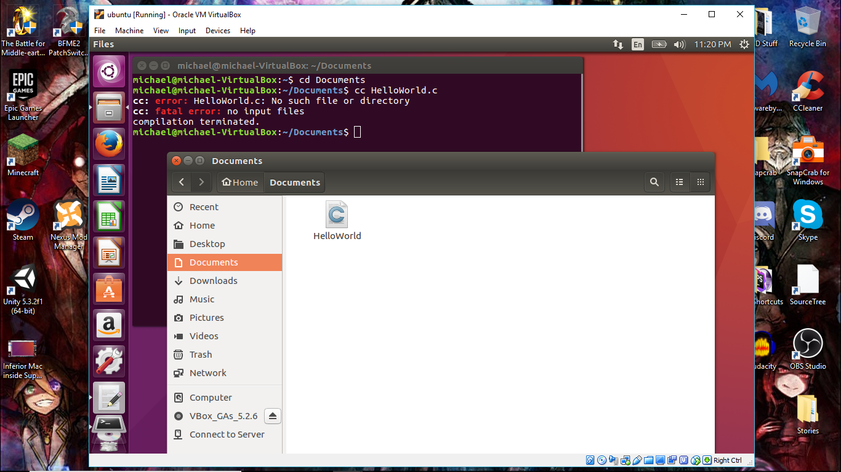

Note: Getting this far has been rather difficult. Learning how to use the virtual machine and getting Ubuntu installed has not been easy. I also have not been able to access the shared file space that I have set up for Ubuntu, so getting anything in and out of the MAC installed on my PC is going to be a nightmare. At one point I tried accessing the files that I had created on my PC within the MAC, and there was no way to access the folder. I had to then go and use the MAC to download Git, Vim, then create the files on the VM itself. I have a feeling that this will not work if we have to create any large projects because the VM can only be allocated so much processing power, because it strains my PC to run it.

*Tips I would need to progress farther are:*

* setting up the ability to execute files on the MAC terminal.
* How to successfully link the shared folder so I can access files within the MAC that are created in the PC.